Thermo Shaker for Microplates—TS400
(Also for Deep-well Plates)
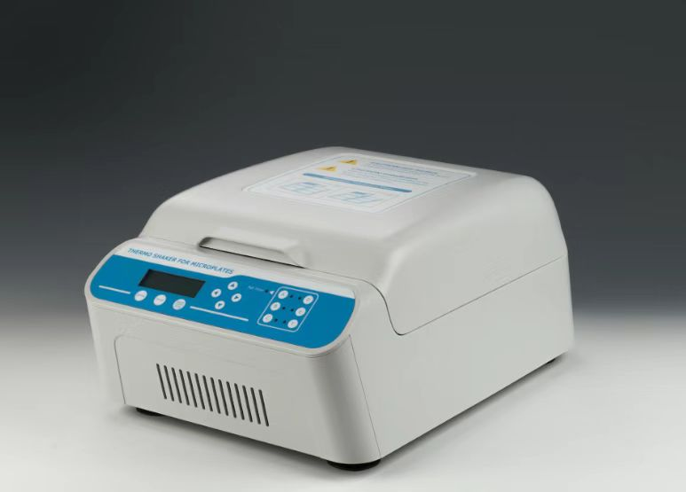

Introduction
TS400 Thermo Shaker for Microplates is a multipurpose thermostatic shaker controlled by brushless DC motor. Its PID intelligent temperature control technology ensures the temperature accuracy, automatically adjusts the heating rate and reduces waiting time. Independent timing function allows timing a single plate, that increases flexibility in processing multiple batches. Wrap-around heating lid design reduces thermal edge effects. It is the ideal automation tool for sample incubation, catalysis , blending and preservation.

Features:
- LCD display. It is easy to setup and use.
- Support 6 standard microplates and deep well plates.
- Support 6 plates timing independently.
- With a wrap-around heating lid design, two options for heating lid temperature control: automatic or manual.
- Automatic preheating function.
- Automatic power recovery function.
- Automatic fan function.
- Temperature calibration function.
- Brushless DC motor, low noise, small interference, free maintenance.
- Built-in software and hardware over temperature protection device, will use more reliable.

Applications:
- Storing enzymes or DNA libraries at your workstation.
- Transporting samples from the field at exactly the right temperature.
- Heating samples in the field.
- Enzyme reactions and deactivations.
- PCR sample preparation.

Parameters
Model | TS400
Temp setting range | 0℃~100℃
Temp control range | RT+5℃~100℃
Time range | 1min ~ 99h59min/∞
Speed range | 200~1600rpm
Orbit | 3mm
Temp accuracy | ≤±0.5℃@37℃*
Display accuracy | 0.1℃
Temp uniformity | ≤±0.5℃@37℃*
Heating time 1 | ＜5min(from 25℃ to 60℃)*
Heating time 2 | ≤20min(from 25℃ to 100℃)*
Auto preheating | Yes
Preheating setting range | 37℃~100℃
Pause function | Yes
Auto resume to run | Yes
Auto fan function | Yes
Independent timing function | Yes
Heating lid temp. control mode | Automatic / Manual
Multi point running | Yes(Max 5points)
Multi cycle | Yes(Max 99times)
Capacity | 6 Microplates or Deepwell plates
Power supply | 480W
Voltage | AC220V or AC110V /50-60HZ
Dimension(mm) | 481x346x228
Weight | 15kg

